Standard Operating Procedure: General Electrical Safety
ESP-01
VinUniversity - MEDAL LAB
Author: Luong Hong Duong (Research Assistant)
Authorization: Professor Simon Park (Principal Investigator)

Purpose of Document/ Scope of applications
This document establishes standard operating procedure (SOPs) and measurement practices for researchers working with electrical devices, equipment, tools, and potentially hazardous energized systems within MEDAL.
The document is intended to serve both as a standardized safety procedure and as training material for new members of MEDAL, providing clear guidelines for the safe operation, measurement, and handling of electrical equipment and energized systems.
This procedure applies to all personnel working within MEDAL, including, but not limited to:
- Principal Investigators (PIs)
- Post-doctoral Researchers
- Research Assistants
- Graduate/Undergraduate Students
- Other personnel authorized to work in the laboratory
- Abbreviation and responsibility
Position | Abbreviation | Responsibility
Principal Investigator | PI | Manage overall safety plan and training plan  Approval of test procedures, work permit, safety training,…
Post-doctoral Researchers | PR | Approval of test procedurers  Test supervision - RA/SU
Research Assistant | RA | Safety SOP author  Test supervision - SU
Graduate Student  Undergraduate student | SU | Following/practice training and safety plan  Weekly training plan
- Basic knowledge
  - Basic operating procedure
-Any work involving electrical equipment, energized systems, machinery, or other potentially hazardous equipment may pose a risk to personnel. Therefore, all personnel working within MEDAL must be able to identify potential hazards associated with their work and take appropriate safety precautions before and during testing or operation.
All planned work must be assessed and classified according to the risk levels defined in the table below. The appropriate training and safety procedures must be completed before work begins.
For any work classified as R2 or R3, the personnel performing the work must consult with their direct supervisor (PI/PR/RA) before commencing the activity.
Level | Example | Requirement
R1 – Low | Computer work, low-energy sensors, simple assembly | General lab training
R2 – Moderate | Soldering, benchtop chemicals, 3D printers, machine tools | Specific training + SOP
R3 – High | Energized exposed circuits, high-energy batteries, welding, pressure systems, reactive/toxic gases, hazardous chemistry | Written risk assessment + authorized user + supervisor approval
- Specific training and SOP will be done by PR/RA depends on the requirement of work
- For all R3 class work, a writen assesment must be submited. ( See LSP-00)
3.2 Identification of possible electrical safety hazards
- Possible electrical hazard:
No. | Electrical Hazard | Possible Cause
1 | Electric Shock | Direct contact with energized conductors or exposed electrical components
2 | Arc Flash / Electrical Arc | Short circuit, accidental contact between conductors, or incorrect connection
3 | Short Circuit | Incorrect wiring, damaged insulation, loose connections, or conductive objects bridging conductors
4 | Overcurrent / Overload | Exceeding the rated current of a circuit, power supply, or electrical component
5 | Incorrect Wiring / Polarity | Reversed polarity, incorrect terminal connections, or wiring errors
6 | Unexpected Energization | Equipment being powered during maintenance, modification, or troubleshooting
7 | Stored Electrical Energy | Capacitors or other components retaining electrical charge after power is disconnected
8 | Damaged Cables / Insulation | Mechanical damage, excessive bending, aging, overheating, or chemical exposure
9 | Improper Grounding / Earthing | Missing, disconnected, or inadequate protective earth connection
10 | Water / Moisture Exposure | Liquid spills, wet hands, condensation, or damp working environments
11 | Incorrect Use of Measuring Instruments | Incorrect measurement mode, range, terminal, or connection
12 | Incorrect Multimeter Connection | Connecting the multimeter to an energized circuit while using an inappropriate measurement mode
13 | Working on Energized Equipment | Performing installation, modification, maintenance, or troubleshooting while power is ON
14 | Exposed Live Parts | Removed covers, open electrical panels, exposed terminals, or incomplete assemblies
15 | Electrical Fire / Overheating | Overloaded circuits, short circuits, loose connections, or inadequate ventilation
16 | Electrostatic Discharge (ESD) | Accumulation and sudden discharge of static electricity
17 | Incorrect Power Supply | Applying incorrect voltage, current, frequency, or power source
18 | Loose Electrical Connections | Improperly tightened terminals, connectors, or wires
19 | Improper / Temporary Electrical Systems | Improvised wiring, exposed connections, or use of non-standard components
20 | Cable-Related Hazards | Improper cable routing, damaged cables, or cables placed across walkways

Mandatory Operation Rules
  - De-energized work
- De-energized work is the default for all SU. Work on exposed energized circuits is prohibited unless there is a documented justification and specific authorization from the PI/PR, based on the associated level of hazard.
Energized work shall only be performed by trained and authorized personnel and under the conditions specified by the applicable SOP and risk assessment.
4.2 Electrical system design and assembly
- Before assembling any electrical system, the complete system and circuit shall be documented using an appropriate circuit diagram or schematic.
The circuit diagram and proposed assembly shall be reviewed and confirmed by the direct supervisor before the system is energized or assembled.
Documentation for each electrical assembly shall clearly identify, where applicable:
- master emergency disconnects
- clearly labelled isolation switches
- appropriate circuit protection
- grounding/earthing
- insulated terminals
- guarded busbars
- emergency stops where appropriate
- interlocks on experimental equipment
- current-limited supplies during development
4.3 Electrical cabinets and enclosure
- Electrical cabinets and protective enclosures shall remain closed during normal operation.
All electrical cabinets containing hazardous or high-voltage components shall be clearly labelled with an appropriate electrical hazard warning sign.
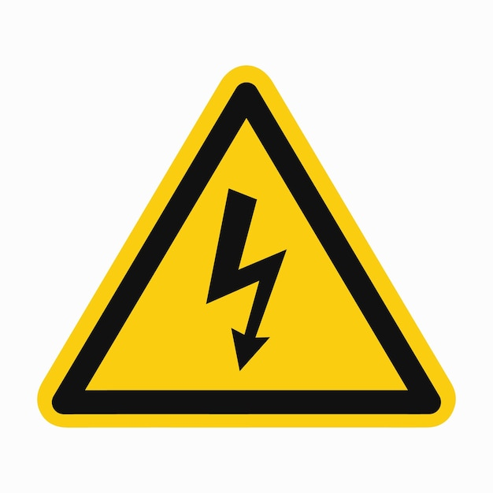
Fig 1: Warning sign for high electrical voltage
- Access to electrical cabinets containing exposed electrical components shall be restricted to trained and authorized personnel.
4.4 Experimental Equipments
- Any equipment that has been substantially modified from its original configuration must have appropriate documentation describing the procedures for disassembly, inspection, and reassembly.
- An inspection schedule shall be established by the responsible research team based on the equipment's design, usage, and associated risks.
- The required inspection interval shall be clearly indicated on a label attached to the equipment. An inspection report shall be completed at each scheduled inspection and verified by an authorized person. Equipment shall not be returned to service if an inspection identifies a safety-critical defect until the defect has been properly addressed and the equipment has been approved for use.
4.5 Lock out/Tag out Procedure (LOTO) and Maintenance
- A Lockout/Tagout (LOTO) procedure shall be implemented whenever maintenance, inspection, modification, or repair requires access to equipment with exposed electrical components or other hazardous energy sources.

- The equipment shall be isolated from all applicable energy sources before work begins, and the absence of hazardous energy shall be verified before personnel access the equipment.

- LOTO procedures shall be performed in accordance with the applicable laboratory safety procedure and risk assessment.
At least two trained and authorized personnel shall be present during maintenance or other high-risk work involving exposed electrical components, particularly where immediate assistance may be required in the event of an emergency.

Emergency Procedure
  - General emergency response
- In the event of an electrical accident or suspected electrical hazard, please follow these steps:
- Stop work immediately and warn others in the area. Do not touch the affected person or electrical equipment if the system may still be energized.
- Disconnect or isolate the electrical supply using the nearest safe emergency disconnect, isolation switch, or main power switch, if this can be done without exposing personnel to additional risk.
- Notify the responsible laboratory personnel immediately.
- If the situation presents an immediate threat to life, fire, smoke, severe injury, or uncontrolled electrical energy, activate the laboratory emergency response and contact the appropriate emergency services.
- Do not resume work or re-energize the equipment until the hazard has been assessed and the equipment has been declared safe by an authorized person.
For specific safety hazard, please use the following links as training before any work is carried out:
https://www.youtube.com/watch?v=Z_AC8dc0hJc
https://www.youtube.com/watch?v=ggJo6m8NZtA

- Training requirements for working personel
All personnel conducting electrical testing, assembly, modification, maintenance, or other activities that may potentially result in an electrical hazard **must complete the required training and have the training properly documented before commencing work**.
The following training requirements shall be fulfilled, as applicable:
1. ESP-01 Training
- Personnel must complete the ESP-01 Electrical Safety Training. A training record must be maintained as evidence of completion.
2. Electrical Safety Training Video
- Personnel must review the designated electrical safety training video. Completion of the training must be documented and confirmed by the direct supervisor.
3. Equipment-Specific Training
- Personnel must complete equipment-specific training before operating or working on equipment where such training is required. Training shall cover the appropriate operating procedures, potential hazards, safety precautions, and emergency procedures associated with the equipment. The completion of equipment-specific training must be documented before the personnel are authorized to use the equipment. No personnel shall conduct work involving potential electrical hazards until all applicable training requirements have been completed, documented, and verified.

-------------- End of document--------------

